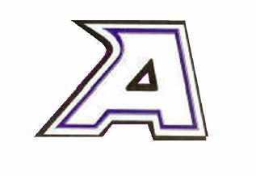
Athens Area Schools
2022-2024

Back to School Safety Guidance

Instruction
Athens Area Schools will continue to offer the following instructional options for all students K-12. Each option will require a semester-long commitment, regardless of which phase we are in.
In Person Learning  With Safety Protocols | - Students will attend school face-to-face at Athens Area Schools in grades K-12, Monday - Friday, beginning August 24, 2022.  - The school day will follow a traditional schedule, with accommodations made to follow safety protocols outlined in this document. All protocols are subject to change based on CCPHD, MDHHS and CDC recommendations, guidance, and mandates.  - Attendance will be based on in person attendance in classes. All grading and assessment protocols of a traditional school year will be followed.  - All curriculum used will be district-approved curriculum based on Michigan Academic Standards.
Full-Time Virtual Learning | - Families will be required to make a semester commitment to this program.  - A full schedule of all core subjects and elective options for students.  - A Michigan certified teacher will be provided, with an Athens Area Schools mentor.  - Students must not have failed virtual courses in the same subject during the most recent academic years.  - The virtual enrollment request must occur within the predetermined timelines established for enrollment and schedule changes.  - Students will be provided with a district Chromebook. Assistance with internet accessibility devices may be available to families in need.  - Students are considered a full time Athens student, and can participate in athletics and extracurricular activities. Devices will be provided to all students, and assistance for internet access may be available.
We want 100% in-person learning every school day, and we want to keep all students and staff as safe as possible!
To do this, the following safety protocols and mitigations strategies will be enforced at Athens Area Schools. Regular review and evaluation will take place throughout the year, working in collaboration with the Calhoun County Public Health Department. Any new mandates from CCPHD, MDHHS, MDE, or the CDC will be enforced.
Safety Protocols: Masks
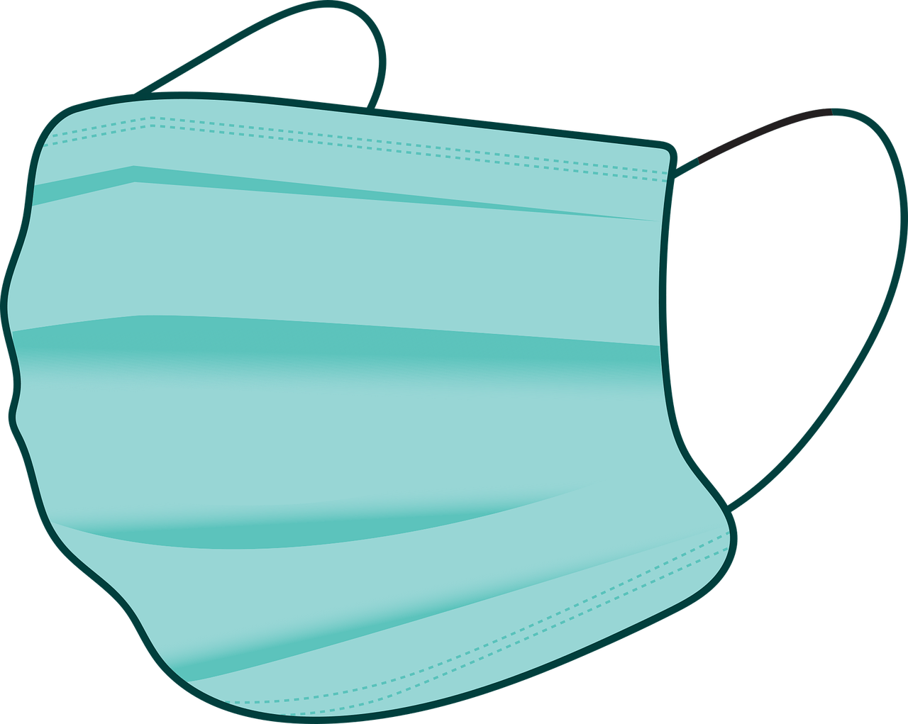
Masks are an important tool to reduce the risk of transmission of the virus, especially for the unvaccinated.
The following are the current requirements related to masks at Athens Area Schools:

Masks may be REQUIRED on buses or any school transportation.
- Federal guidelines mandating the wearing of masks by all individuals, students and staff, regardless of vaccination status, while on public transportation, including school buses may be necessary. A doctor’s note is required to be medically exempt from wearing a facial covering. (See “Busing and Student Transportation”)
  - A list of students who are medically exempt will be provided to all school personnel who have a legitimate educational interest.

Masks will be OPTIONAL for any individual in the school or on school grounds.
- If a building has an outbreak of active COVID positive students, then masking will may be required. The optional use of masks will be continuously reviewed and evaluated based on the community transmission risk level as reported by the CCPHD’s Current County Risk Level Guidance found at https://www.calhouncountymi.gov/departments/public_health_department/schools_covid_resources.php.
Safety Protocols: Vaccinations
- The district will advocate for all eligible students and staff to get vaccinated. This includes, but is not limited to, providing information upon request on how to go about and where to be vaccinated.
- Vaccinations will NOT be required for all students and staff for in-person attendance.
Safety Protocols: Hygiene
- The district will provide adequate supplies to support healthy hygiene behaviors (including soap, hand sanitizer with at least 60% alcohol for safe use by staff and students, paper towels, tissues, and signs reinforcing proper handwashing techniques).
- Portable hand sanitizing stations will be set up at entrances and throughout school buildings.
- Hand sanitizer will be available in all classrooms.
- The district will post CDC approved flyers in all bathrooms and common areas AND the district and our school nurse will educate students and staff at the return to school from a closure to:
  - Teach and reinforce handwashing with soap and water for at least 20 seconds and/or the safe use of hand sanitizer that contains at least 60% alcohol.
  - Educate staff and students on how to cough and sneeze into their elbows, or to cover with a tissue, as well as proper techniques for disposal of used tissues.
  - Location of hand washing stations and hand sanitizer.
  - Safe procedures for opening doors.
- Students and teachers will be encouraged to wash hands with soap and water every 2-3 hours.
- All students are strongly encouraged to have their own school supplies to limit sharing of personal items and supplies such as writing utensils.
Safety Protocols: Spacing, Movement, & Access
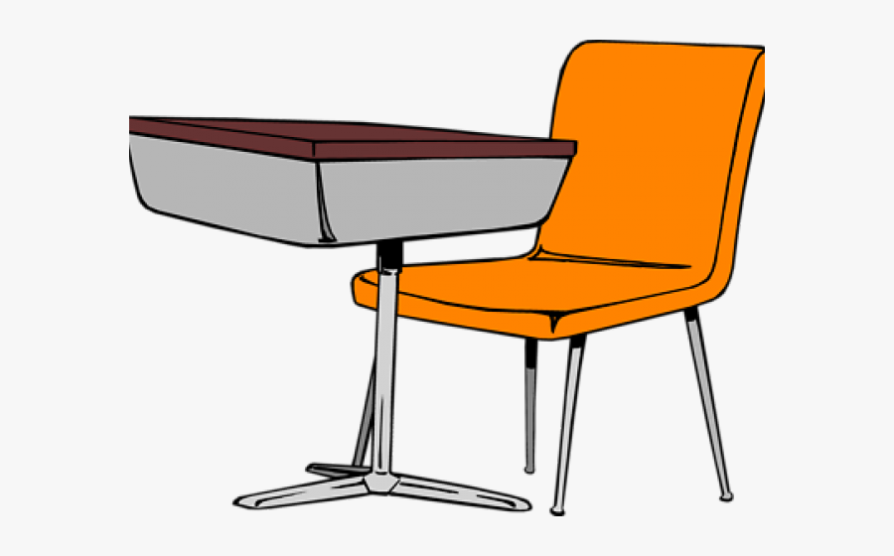
Classroom Space
- Class sizes should be kept to the level afforded by necessary required spacing guidelines.
- In classrooms, desks, tables, and/or student workstations will be set up in the following manner as much as feasible:
  - As far apart as the classroom space allows.
  - All facing in the same direction toward the front of the classroom if required.
- Teachers should maintain six feet of spacing between themselves and students as much as possible.
- Seating charts will be maintained for contact tracing purposes.
- Classrooms that have windows that can open, will be kept open as much as possible, weather permitting. Considerations will be made for students with allergy-induced asthma. All opportunities to increase fresh air exchange will be a priority.
Hallways and Common Areas at East Leroy Elementary:
- The building will not be open until 8:00 am. All CCPHD recommendations will be implemented. Examples include: Students being dropped off by family members will go immediately to the designated room and sit in socially distanced chairs. Once dismissed, students will move through the breakfast line and proceed to their classrooms. Students who ride the bus will be dismissed one bus at a time by staff. Students will then proceed through the breakfast line and go to their classrooms.
- If required only one classroom will be in the hallway at one time. As a result bathroom breaks taken as a class will be scheduled.
- Breakfast will be served in classrooms.
Hallways and Common Areas at Athens Jr./Sr. High School:
- The building will not be open until 6:50 am. All CCPHD recommendations will be implemented. Examples include: Students will be dropped off at their designated door and required to go immediately to their assigned area in order to minimize congregating in hallways and common areas. Three entrances will be used for students to enter the building. The northernmost entrance/exit will be used by sixth grade students. The “main” entrance will be used by seventh and eighth students. The southernmost entrance/exit will be used by those students in grades 9-12. These entrances will also be used by the same groups of students to exit the building at the end of the school day.
Visitors
- Family members or other guests will have appropriate access for entrance in the school building depending on current requirements and conditions. Prior to entering the building, adult guests (any non-school employee) may be required to:
  - Answer a short screener for symptoms.
  - Be recommended to wear a facial covering.
  - Wash/sanitize hands.
  - Sign in and sign out, including date and time, when entering and exiting the building.
Safety Protocols: Screening Students and Staff
Students or Staff Symptomatic at School
Based on current CCPHD requirements any and/or all of the following may be required:
- The school nurse will serve as the district’s “quarantine officer” to monitor and care for students/staff who become ill at school.
  - If the school nurse is not available, an alternate staff member will be identified to individuals in the quarantine room.
- From the time of identification of potential infection, the individual will be monitored and a log-sheet of activity will be maintained until the student or staff member is safely removed from the building.
- Parent communication will be made immediately with clear and concise directions on where and how to pick up the student and where to report for testing.
- Test results may be requested before the students can return to school.
- During the time of quarantine, the student will be asked to self-identify the location and individuals they came into contact with for the last 48-72 hours to the best of their recollection.
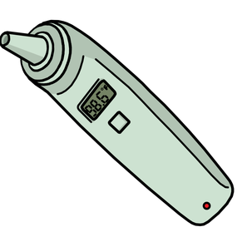
- The health department will be contacted after parents have been notified to assist in contact tracing and notification of vulnerable individuals.

Student Screening at Home
- Families are encouraged to check their child’s temperature at home every morning using oral, tympanic, or temporal scanners; students with a temperature of 100.4 or greater should stay home and consider coronavirus testing if symptoms of COVID-19 are present.
- Families are encouraged to monitor their children for symptoms of COVID-19. The presence of any symptoms, including cough or shortness of breath, should prompt the family to keep the student home from school and to follow up with a primary care provider. All families will be provided with an at-home self-screener checklist to help with this at-home monitoring.

Staff Screening
- All school staff are required to conduct a health safety self-assessment at home prior to coming to work.
- Staff who are unable to work due to displaying COVID-19 symptoms will be required to report this to the school in a timely fashion.
- Positive tests for staff members will result in a required isolation away from school following direction from public health officials.

COVID Testing
- No mandatory testing is required at this time, but Athens Area Schools will comply with all screening requirements as mandated by any MHSAA, CCPHD, MDHHS, MDE, or CDC order.
- The district will work with CCPHD to continuously review and evaluate best practices based on the CDC mitigation risk-level guidance as reported by the CCPHD’s Current County Risk Level Guidance found at https://www.calhouncountymi.gov/departments/public_health_department/schools_covid_resources.php.
Safety Protocols: Responding to Positive Tests Among Staff and Students
Contract Tracing
- If a student, staff, or visitor tests positive for COVID-19, the district will work with the CCPHD to establish appropriate responses, from communicating with parents to potentially closing buildings.
- The school is required to report any communicable disease, as required by law, and work in collaboration with the Calhoun County Public Health Department on all contact tracing procedures for quarantines issued by the CCPHD.
- All contact tracing guidelines established by the Calhoun County Public Health Department will be followed for all school-associated cases at Athens Area Schools.
- Athens Area Schools will comply with all testing requirements as mandated by any CCPHD, MDHHS, MDE, or CDC order.
Safety Protocols: Food Service, Gathering, Extracurricular Activities

Breakfast
- Breakfast could be served in classrooms for elementary students if required. Students in MS/HS that want breakfast can go through the line to get a grab & go breakfast to take back to their first hour classroom to eat. If allowable they may eat in the cafeteria.

Lunch
- K-5 students will eat in their classrooms when required. If not required they will eat in the cafeteria.
- MS/HS students will eat in cohorts in classrooms or in designated areas such as the cafeteria.

Assemblies/Field Trips/Ativities
- All indoor and outdoor gatherings will comply with guidelines in this plan and lawful mandates.
- Extracurricular events will be considered on a case-by-case basis.

Safety Protocols: Athletics
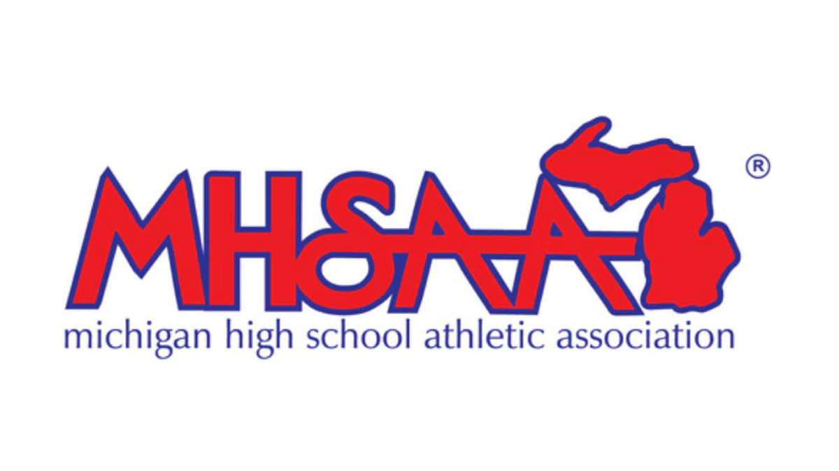
Athens Area Schools will comply with all athletics requirements as mandated by any MHSAA, CCPHD, MDHHS, MDE, or CDC order. The AAS Athletic Director will review and become familiar with all guidance published by the MHSAA and share this information with coaching staff, students, and parents.

Athletics will follow all guidance published by the MHSAA.

Safety Protocols: Cleaning
- The district will create schedules to meet cleaning recommendations and protocols with EPA-approved disinfectant for all required areas including:
  - Frequently touched surfaces including light switches, doors, benches, bathrooms.
  - Libraries, computer labs, arts, and other hands-on classrooms, if used by students.
  - Classroom manipulatives, books, and educational games.
- The cleaning and sanitizing desks and workstations will follow the CCPHD recommendations for daily cleaning.
- Appropriate PPE and cleaning supplies will be made available to all classroom teachers and staff in each building.
- Custodial staff will be available during the day to clean and check high traffic areas.
- District level administrators and building operations will meet to review and assess the plan for the cleaning and disinfecting of all buildings.
- Promoting fresh air exchange in classrooms and buildings will be a priority.
Safety Protocols: Busing and Student Transportation
On the Bus
We will comply with all MHSAA, CCPHD, MDHHS, MDE, or CDC orders, the following are possible rules.
- All students in grades K-12, if medically feasible and required by the federal government, will wear facial coverings while on the bus.
- A doctor’s note must be provided for a student to be considered medically exempt from wearing a facial covering.
  - All individuals are expected to bring their own mask prior to entering the bus, however, disposable face masks will be available at the entrance of the bus in the event that a student does not come to the bus with the necessary item.
- Communication will be provided to bus drivers regarding students that have a doctor’s note exempting them from wearing a mask for medical reasons.
- All individuals that enter the bus will be required to use hand sanitizer before entering the bus. Hand sanitizer dispensers will be located at the entrance of every bus, and the district will ensure that proper supplies are available.
- Bus drivers will create a seating chart to group families together and promote social distancing as much as feasible. Students are required to sit in their assigned seats.
- Weather permitting, bus drivers will keep windows open on the bus both when in route and when stopped, to help increase air circulation.
- If a student becomes sick during the day, he/she will not be allowed to ride the bus home. Protocol outlined in “Screening Students and Staff” (above) will be followed for a student that becomes symptomatic while at school. If a driver becomes sick during the day, they must follow protocols for sick staff outlined above and must not return to drive students.
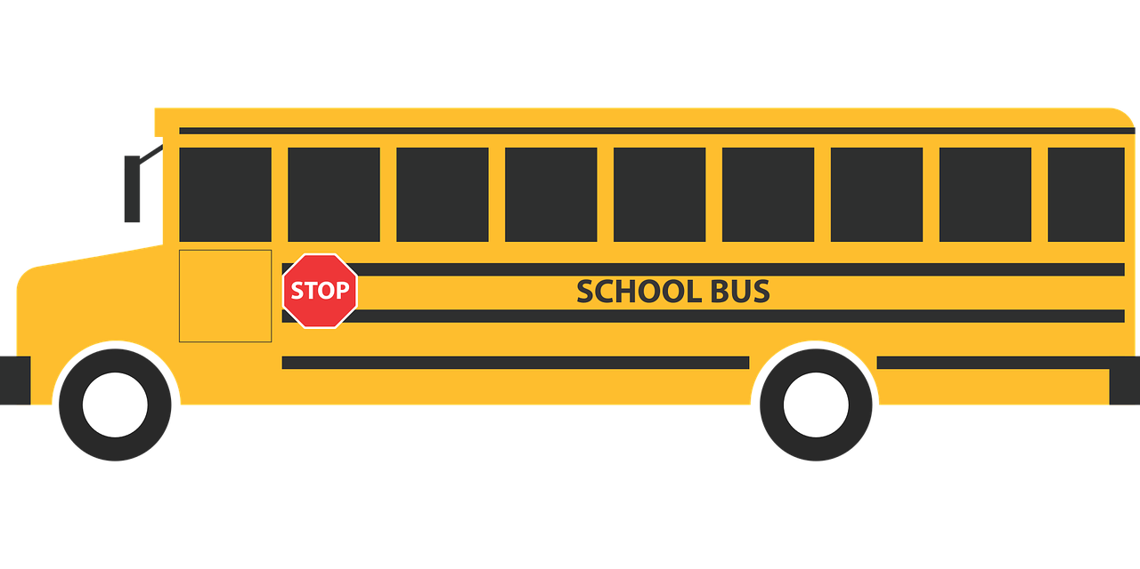
- Signage will be added to each bus to address the use of face masks for all passengers and drivers, use of hand sanitizer, and cleaning protocols.
- To help maintain safety, no bus passes will be allowed without administrative approval.

Non-Compliance on the Bus
- Students that choose to repeatedly remove their face covering or not comply with their assigned seat will revoke their privilege to ride the school bus until further administrative review.

Cleaning the Bus
- All buses will be cleaned and disinfected before each transportation run. This will include frequently touched surfaces in the vehicle, such as: surfaces in the driver’s cockpit, hard seats, arm rests, door handles, seat belt buckles, and any equipment, such as car seats, wheelchairs, walkers, and adaptive equipment being transported to schools daily.
- No students will be present when a vehicle is being cleaned.
- Weather permitting, bus drivers will keep doors and windows open when cleaning the vehicle and between trips to let the vehicles thoroughly air out.
- All necessary cleaning supplies and PPE for cleaning will be provided by the district.
Safety Protocols: Medically Vulnerable Students
Athens Area Schools will systematically review all current plans (e.g. Individual Healthcare Plans, Individualized Education Programs, Individualized Family Service Plans, or 504 plans) for accommodating students with special needs and update care plans as needed to decrease their risk for exposure to COVID-19.

Mental & Social-Emotional Health
- Comprehensive lists of wellness resources are available to both staff and students.

- Staff will be trained by and work with the Calhoun Intermediate School District in the implementation of the Critical Incident Stress Management / Debriefing protocols, as well as use our Crisis Prevention and Response Plan protocols as needed ((e.g., loss of student, loss of a school staff member).

