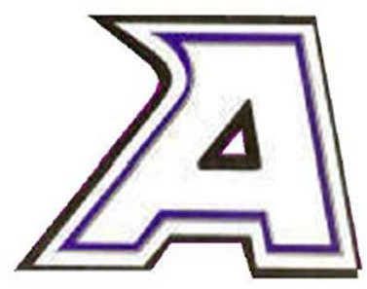

ATHENS AREA SCHOOLS

JOB POSTING

TITLE: Paraprofessional [1 on 1 aide for ASD Student]
BUILDING: Athens Jr. / Sr. High School
HOURS: Hours and condition as per contract
(Number of hours dependent upon enrollment)

Position available for the [Feb] 2023-24 school year. Description: See attached job description.
For detailed job requirements, please contact Athens Jr. / Sr. High School Principal, John D. Thompson at 269.729.5414.

Letters of intent should be sent to:

John D. Thompson, Principal
Athens Jr./Sr. High School
300 E. Holcomb St.
Athens, MI 49011
Email: thompsonj@athensk12.org
Telephone: 269.729.5414
DEADLINE: Until filled.
Posted: January 11, 2024

January 11, 2024

Athens Area Schools
300 E. Holcomb St., Athens, Michigan 49011
(269) 729-5414 — www.athensk12.org
Athens Jr/Sr High School 269.729.5414

POSITION: Paraprofessional [1 on 1 aide for ASD Student]
LOCATION: Athens Jr. / Sr. High School
REPORTS TO: Building Principal

GENERAL DESCRIPTION:
- This position requires an individual with the ability to establish positive rapport with students and their families. The individual working as a Paraprofessional must be able to take direction and work closely with other staff members such as teachers and administrators. Communication is a requirement with the Paraprofessional being adept in oral communication as well as written communication. Additionally, this position requires frequent meetings with school administrators, teachers, and other staff to communicate information, data, and alternative problem solutions. This position requires that the individual be self-motivated and a self-starter. Other duties as assigned.

QUALIFICATIONS:
- Must have passed the ETS Parapro Assessment or hold the equivalent of an Associate’s Degree from an accredited university.
- Previous experience in a similar role preferred.

ESSENTIAL PERFORMANCE DUTIES AND RESPONSIBILITIES:
- Background knowledge of working with young children.
- Assist the classroom teacher with implementation of classroom activities and lesson plans including the implementation of behavioral intervention plans.
- Attend weekly staff and team meetings and other meetings as appropriate and requested.
- Assist in planning and implementation of educational activities.
- Maintain student behavior through appropriate and approved interventions and approved techniques.
- Assist students in meeting educational goals while providing appropriate academic interventions as directed by classroom teacher.
- Assist in the preparation of instructional materials for teaching and for display in the classroom.
- Independently lead small group activities.
- Assist instructional staff in the supervision of students during lunch and recess times.

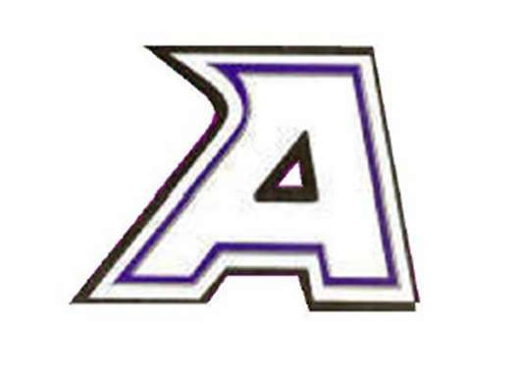
Athens Area Schools
•
300 E. Holcomb St. Athens, MI 49011
(269) 729-5414 — www.athensk12.org
Athens Jr/Sr High School 269.729.5414

- May be asked to regularly lift 50 lb. individually and or push over 100 lb.
- Understand and be aware of medical needs of students; following medical protocol under the supervision of a nurse as appropriate.
- Maintain documentation of student progress relative to student academic and non- academic goals and objectives
- Maintain confidentiality including not interfering with teacher-parent communication.
- Adhere to all board policies.
- Supervise students when the teacher is not present.

Knowledge of:
- Academic, social, and behavioral characteristics of elementary level students.
- Behavior management and behavior shaping strategies, techniques and methods, and conflict resolution procedures.
- Socio-economic and cultural background differences of the school population.
Ability to:
- Plan, organize, develop, and conduct a comprehensive teaching and instruction program for students at the elementary level.
- Implement appropriate and effective learning experiences provided by classroom teacher for students from a wide range of socio-economic levels and cultural backgrounds.
- Assist in providing a motivating and stimulating learning environment.

OTHER SKILLS and ABILITIES:
- Ability to maintain composure under stressful conditions.
- Develop effective working relationships with students, staff and the school community.
- Be able to meet multiple demands from several people.
- Ability to be a team player and be willing to work well with others.

LANGUAGE SKILLS:
Ability to read, analyze, and interpret professional periodicals, professional journals, technical procedures, or government regulations. Ability to write reports, business correspondences, and procedure manuals. Ability to effectively present information and respond to questions from staff, students, parents, and other personnel as appropriate.

MATHEMATICAL SKILLS:
Ability to apply concepts such as fractions, percentages, ratios, and proportions to practical situations.

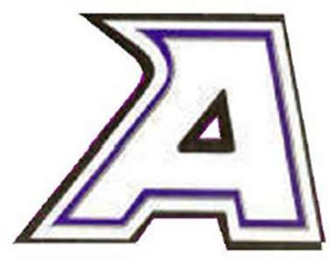
Athens Area Schools
300 E. Holcomb St. Athens, MI 49011
(269) 729-5414 — www.athensk12.org
Athens Jr/Sr High School 269.729.5414

REASONING ABILITY:
Ability to solve practical problems and deal with a variety of concrete variables in situations where only limited standardization exists. Ability to interpret a variety of instructions furnished in written, oral, diagram, or schedule form.

OTHER SKILLS AND ABILITIES:
Ability to apply knowledge of current research and theory to instructional program; ability to plan and implement lessons based on school objectives (school improvement plan goals) and the needs and abilities of students to whom assigned. Must have essential technology skills, i.e. skilled at PC computer, laptop, and other educational technology. Ability to establish and maintain effective working relationships with students, peers, parents, and other community members. Must possess the ability to speak clearly and concisely in written and oral communication. Must be able to meet multiple demands from several people. Must be organized and meet timeline requirements.

PHYSICAL DEMANDS:
While performing the duties of this position, it is required to regularly climb or balance, stoop, kneel, crouch or crawl, and talk/hear. Exposure to continuously standing, walking, and occasionally running may occur. The individual may frequently bend or twist at the neck and trunk, squat, reach above the ear or reach forward and repeat the same gross and hand fine motion more than the average person. The employee may occasionally lift and/or move up to 50 pounds. Specific vision abilities required by performance of this position include close and distance vision.

WORK ENVIRONMENT:
While performing the duties required by this position, the employee may work indoors or outdoors and occasionally in temperatures above or below 95 to 10 degrees Fahrenheit. The noise level in the work environment is usually loud. The employee is frequently exposed to infection at a greater risk than the average person. The employee is directly responsible for the safety, well- being, and work output of students. While performing the duties of this job, the employee is regularly required to stand, walk, and talk or hear. The employee frequently is required to use hands to finger, handle, or feel objects, tools, or controls and stoop, kneel.

Athens Area Schools
300 E. Holcomb St. Athens, MI 49011
(269) 729-5427 — www.athensk12.org
Athens Jr/Sr High School 269.729.5414

DEADLINE FOR SUBMISSION OF MATERIALS:
Until the position is filled.

PLEASE SEND COVER LETTER, RESUME, CREDENTIALS, AND THREE REFERENCES TO:
Mr. John D. Thompson, Principal
Athens Jr. / Sr. High School
300 E. Holcomb St. Athens, MI 49011
Telephone: (269) 729-5414
Or send in a PDF attachment via email to: thompsonj@athensk12.org

The employee shall remain free of any alcohol or non-prescribed controlled substance abuse in the workplace throughout his/her employment in the District.

The work environment characteristics described here are representative of those an employee encounters while performing the essential functions of this position. Reasonable accommodations may be made to enable individuals with disabilities to perform the essential functions.

Athens Area Schools will comply with Titles VI and IX of the Civil Rights Act with Section 504 of the Rehabilitation Act of 1973 as amended. No person on the grounds of race, color, sex, national origin, or handicap will be excluded from participation in, be denied the benefits of, or otherwise subjected to discrimination under any program or activity.

The district will comply with the Michigan Handicapper’s Civil Rights act of 1977 regarding employment and utilization of educational facilities without discrimination because of religion, race, national origin, age, sex, height, weight, marital status or handicap.

